**CP Club 365 Days Challenge**

**Programming language – C++**

**Problem Statement**

<https://www.codechef.com/problems/CANDY123>

Git :- <https://github.com/Vedantbharad2603/CP_club_365_Days>

**Your Code**:

// 0x96Day of 0x365Days challenge

// VEDANT BHARAD

// 21-1-2023

#include <bits/stdc++.h>

using namespace std;

string Candies(int a,int b) {

    int c=1,toeat=1;

    while (c!=0)

    {

        if(a<0 || b<0)

        {

            c=0;

        }

        else

        {

            if(toeat%2==0) //Bob

            {

                b-=toeat;

            }

            else //Limak

            {

                a-=toeat;

            }

        }

        toeat++;

    }

    if(a>b)

        return "Limak";

    else return "Bob";

}

int main() {

    int t;

    cin >> t;

    while (t--) {

        int a,b;

        cin>>a>>b;

        cout<<Candies(a,b)<<endl;

    }

    return 0;

}

**Output (Screen Shot)**:

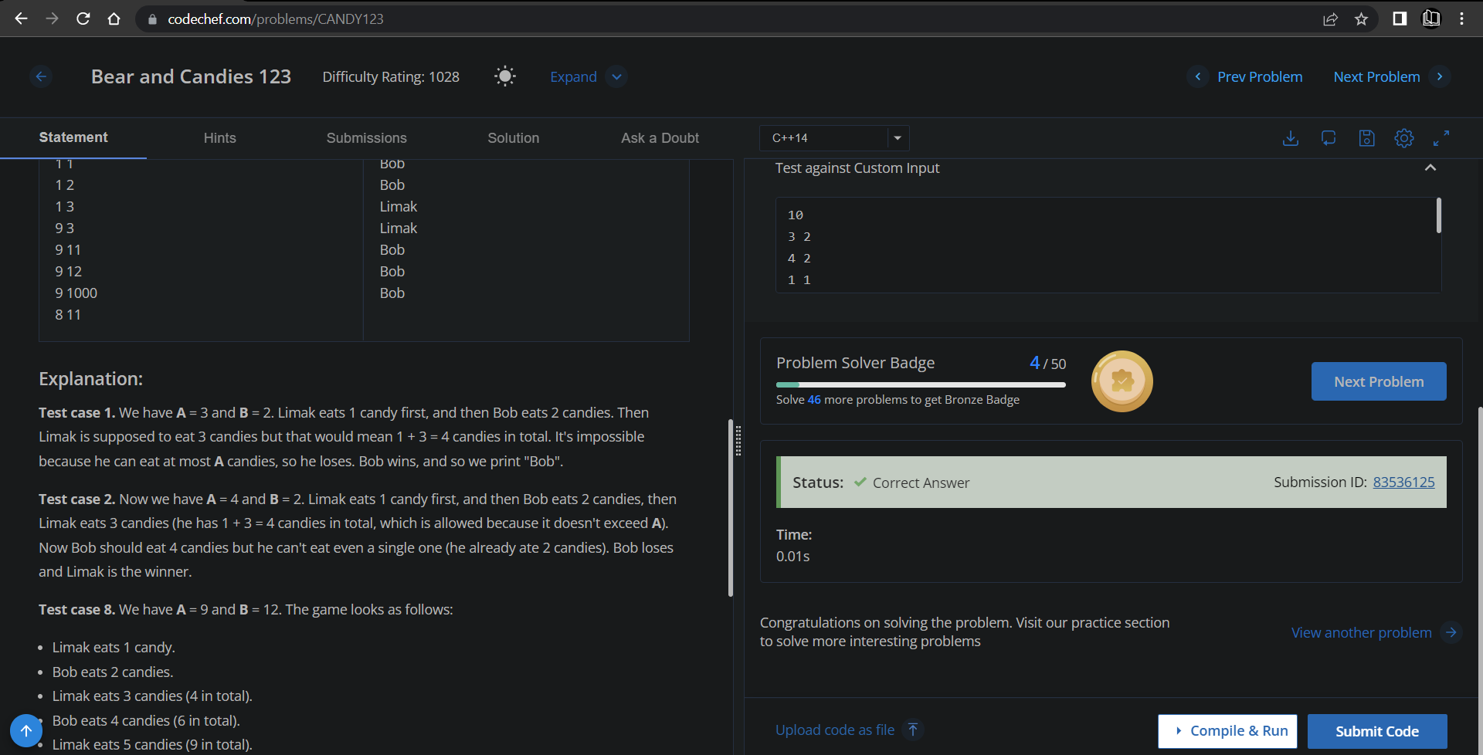

**Understanding about problem:**

* In this task I need to return the winner name of the game which is given in statement if any person need to eat more candies then his limits then that person will lose the game.

Note: If you can't understand the problem, feel free to contact us and we'll help you. Please don't copy and paste from anywhere.

ALL THE BEST

Team CP Club